WASTE AUDIT 2022
COMINGLED
On November 30th, 2022, we performed a waste audit on our comingled recycling. A waste audit is when you take a material stream and analyze it through sorting and measuring things like weights, volumes, anomalies, and any other categories that may be relevant.

WHY DID WE DO THAT?
We wanted to see what our comingled recycling consisted of. Recycling materials are commodities, and the quality of the product affects prices or even the ability of items to be recycled. Figuring out what’s inside the containers we ship gives us data such as contamination rates, amounts of high and low value plastic, and what materials we need to focus on keeping out of the stream. Also, we received help from the AmeriCorps through a grant, which made this project possible.

WHAT WERE WE LOOKING FOR?
Ideally, we wanted as much data as possible. As the project got closer, we learned that we would be getting less AmeriCorps members than anticipated so we had to adjust how many categories we could feasibly sort through. We focused on Plastic, Tins, Bulky Rigid Plastic, Water Bottles, and Trash. We also put aside any items that were not only considered contamination, but were dangerous, such as syringes.

HOW DID WE PERFORM THE AUDIT?
We closed off the area around Comingled compactor #4 and built a corral out of snowplows and blocks. Using our Roll-off truck, we dumped material out of a full and pre-weighed comingled container onto the ground. This material was shoveled onto two sorting tables to be gone through by hand using seven people. Trash, Tins, Plastic, and Water Bottles were sorted into 32-gallon trash barrels. When the barrels were full, they were emptied into larger containers to be weighed at the end. The recyclable Plastic was dumped straight into the nearby compactor and the Bulky Rigid Plastic thrown into the loader bucket and weighed at the end. Afterwards, we re-weighed the container on the truck to determine how much total material we dumped and then weighed all the sorted material. Because the recyclable Plastic went back into the compactor, that weight was determined by adding up the sorted material and subtracting from the total material analyzed. Due to time, we only weighed several 32-gallon barrels of materials throughout the day to get an average weight per barrel. We set aside the more notable items on a table.

WHAT DID WE FIND OUT?
Here is the data that we gathered.

Material | Weight (lbs) | Barrels (32 gal) | % by Weight | % by Volume
Plastic | 600 | 43 | 53% | 60%
Tins | 300 | 14 | 26% | 19%
Trash | 160 | 7 | 14% | 10%
Bulky Rigid | 40 | 6 | 4% | 8%
Water bottles | 40 | 2 | 4% | 3%
Total | 1140 | 72 | 100% | 100%

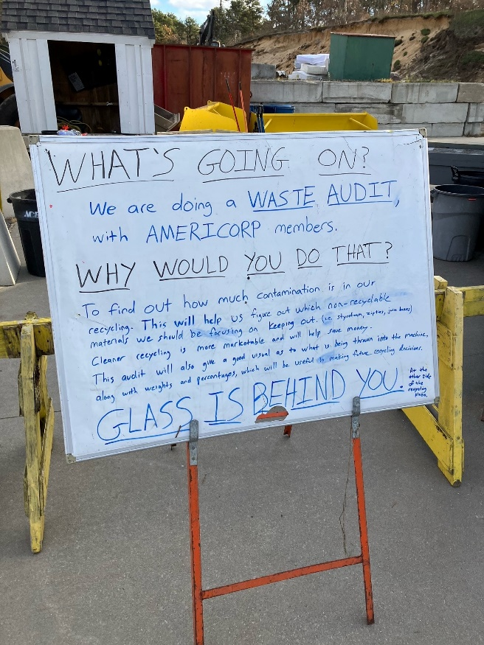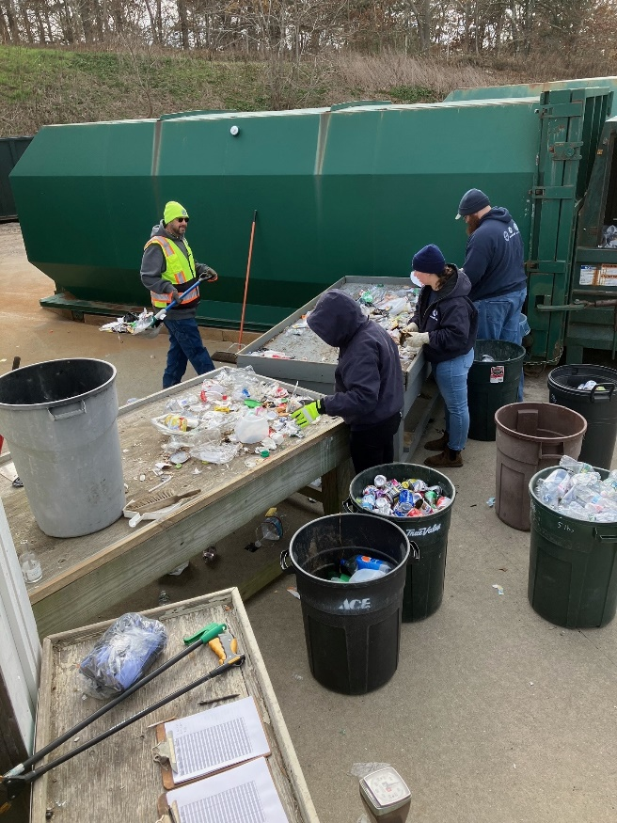

Overall, we were very happy with the quality of the materials. Recycling is measured by weight and 83% of the materials we sorted were able to be recycled. These items were of the right type and clean, meaning free of food, dirt, tanglers, or other contaminants. That gives us a contamination rate of 17%.
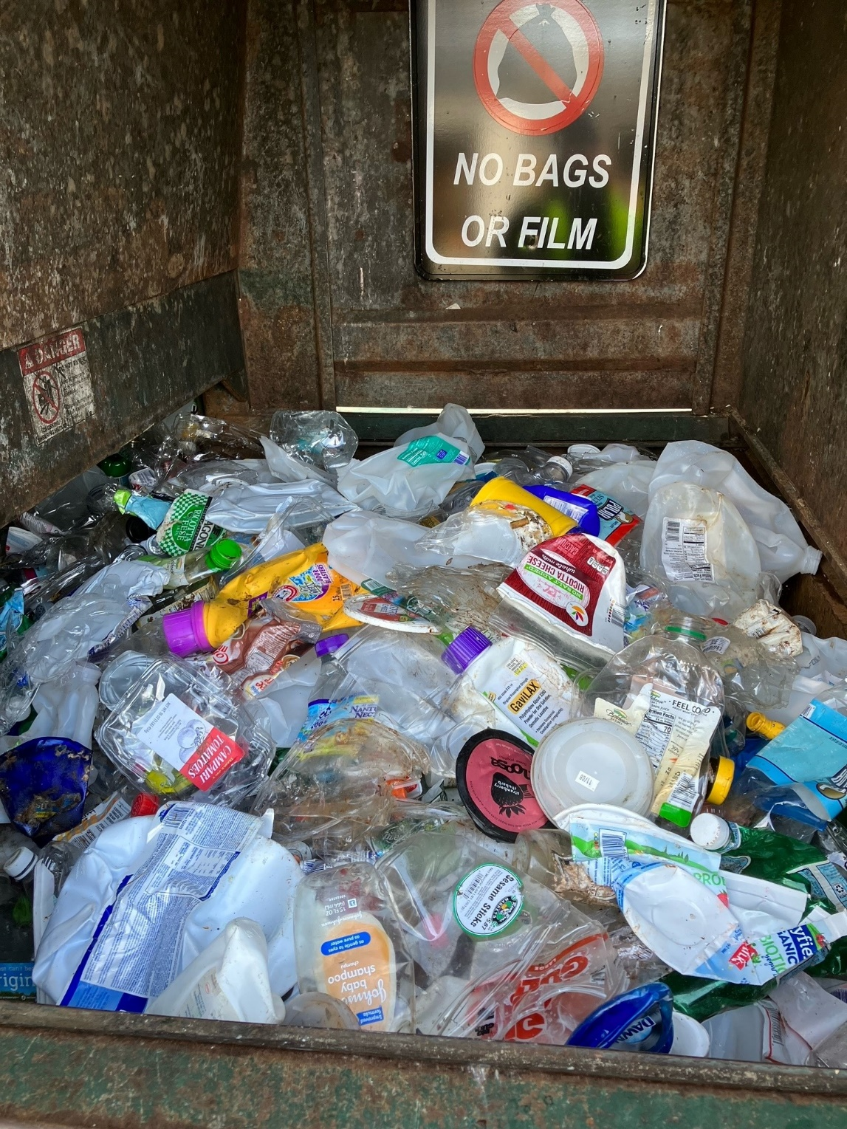
There were 495 Water Bottles (4%) found in the material. The vast majority of these were Poland Spring 16.9 oz bottles. We placed these items in a separate category because Wellfleet has had a commercial single-use water bottle ban in place since September 2021 and thought it could be a useful data point in the future.
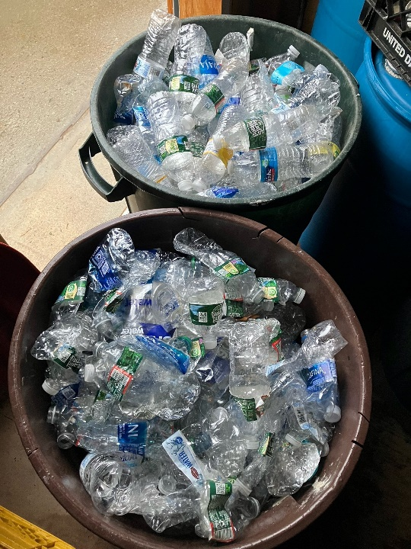
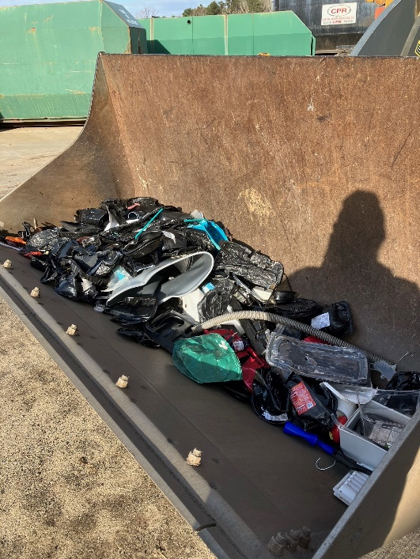

Most of the Bulky Rigid Plastic that we pulled out was not truly Bulky but because it was black, it cannot be recycled with our comingled due to the machinery at the recycling facilities. The Rigid plastic is handled differently and that is why we ask people to put black plastic in with Bulky Rigid.
The other non-recyclable items (Trash) made up 14% of our material. Most of these items consisted of plastic film or bags (often recyclable material but cannot be mixed into our collection system), or cheap brittle cookie trays which are not recyclable plastic. It also contained high value plastic bottles that became trash due to still having food inside, such a salad dressing.
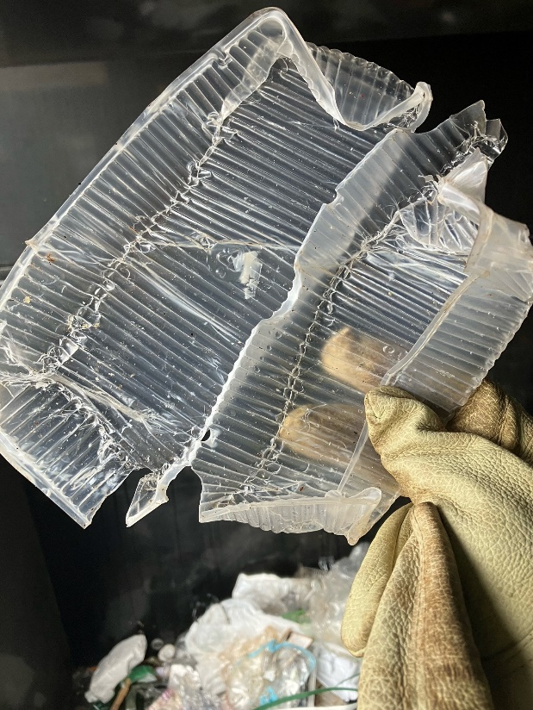
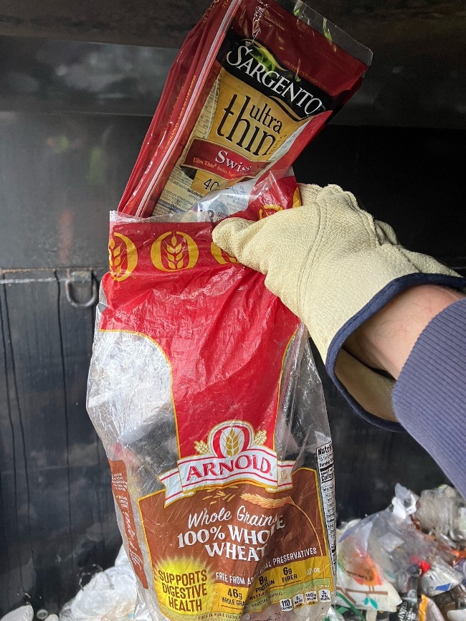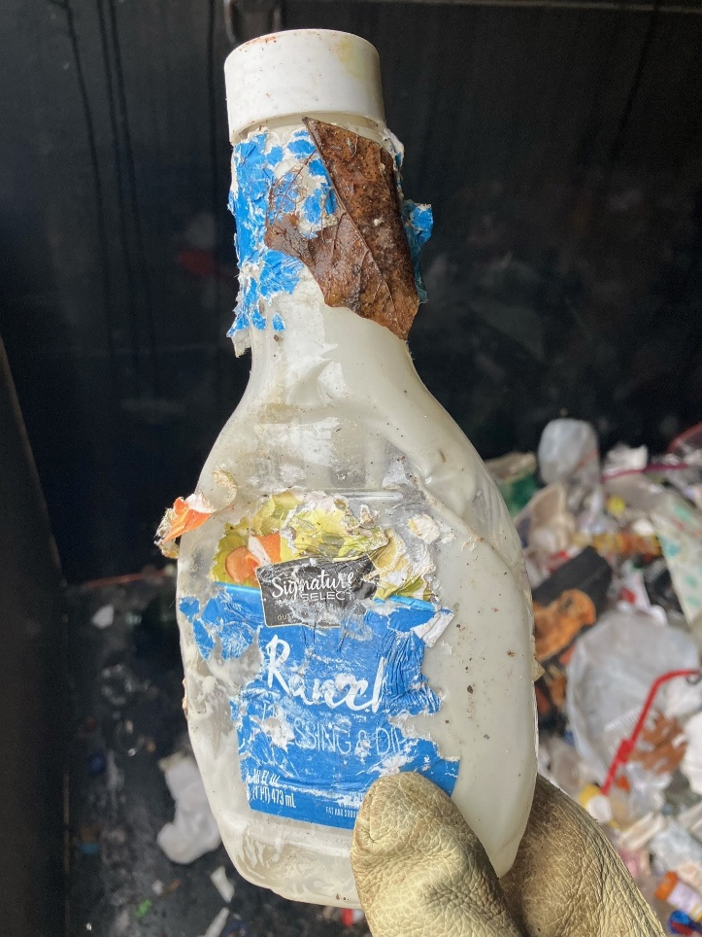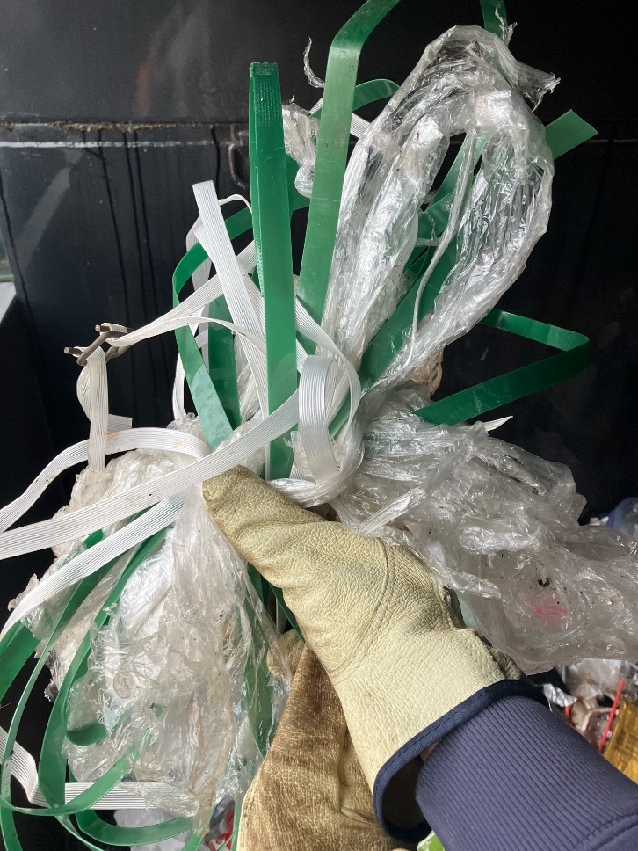

There were some materials found that had absolutely no business in the recycling. These included 5 syringes, 1 Covid test, feminine products, a dead mouse, most of a camera, hairy socks, water filters, fishing line, batteries and electronics, and some unknown materials.

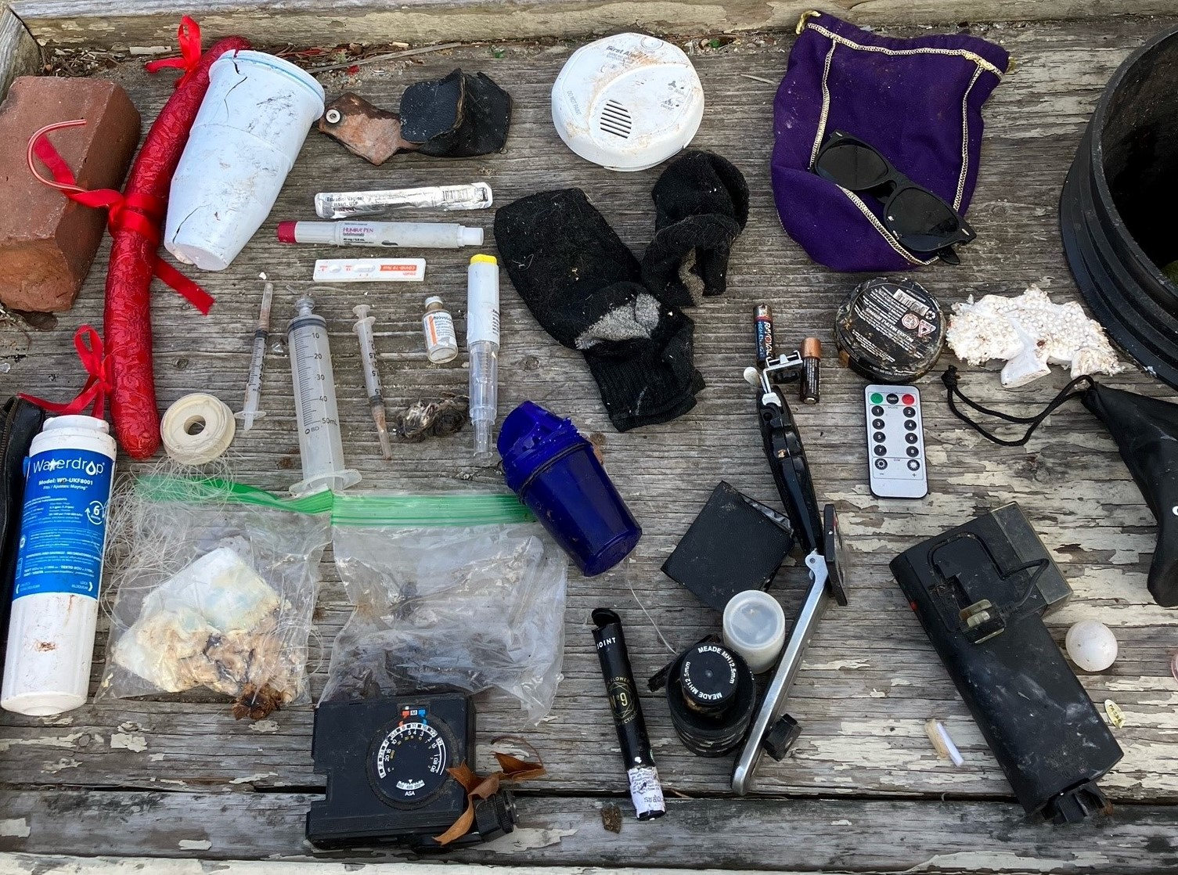

There were also at least 6 pairs of sunglasses found, which are not recyclable but may be an item to focus on.
We also witnessed something that most people would not believe, but those of us in this business see all too often. While we were at lunch, someone, for some reason, put all their cardboard on our plastic sorting tables, still full of plastic, and blocked by sawhorses and “Out of Service” signage. This is what we’re up against daily.
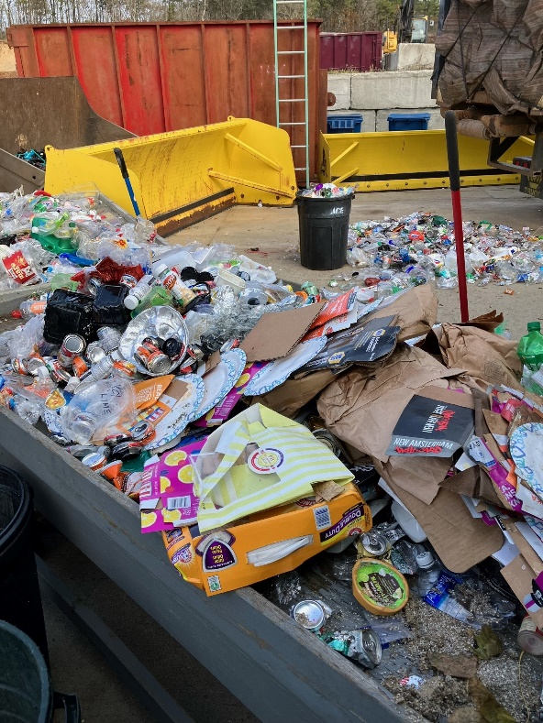
SOME FACTORS THAT AFFECT OUR DATA
When we planned this project, the thought was there could be upwards of 13-15 people to work. With only 7 people, we had to cut back on the number of categories we would separate out and we did not have time to weigh and record each barrel, so we took averages to get our volumes. However, all the weights are accurate to within 20 lbs., which is our vehicle scale’s margin of error.
Because we had fewer people, we only sorted the very tail end of the container. At 1,140 lbs., this is only 20% of the 5,320 lbs. of comingled on the truck. This can affect things because the compactors push material into the containers to fill them. Only when the material inside reaches all the way back to the ram will it start to crush. Due to pressures and physics, the material in the back of the container, closest to the ram, will be the most crushed and therefore densest. It also means that the material we sorted is only representative of a small window of time (i.e., a weekend during this time of year) where sorting the entire container would span material over several weeks.
Throughout the day, the sorting tables became covered in small items and debris as the larger things were sorted. While anything the size of a nip bottle or smaller is not recyclable due to size, we needed to clean off the tables frequently to have a safe workspace and because of time constraints, some recyclable items were missed. The amount would not have been enough to affect our data but for the sake of accuracy it is included with the hope of a more thorough audit in the future.

SO, WHAT NOW?
We learned many things from this Waste Audit. Most importantly, it showed a contamination rate of 17%. That’s under the national average of 25% (EPA) but we would like to get to 10% or less. To do that, we will focus on educating people about the contaminates we saw such as plastic bags, black plastic, six-pack holders and cookie trays.
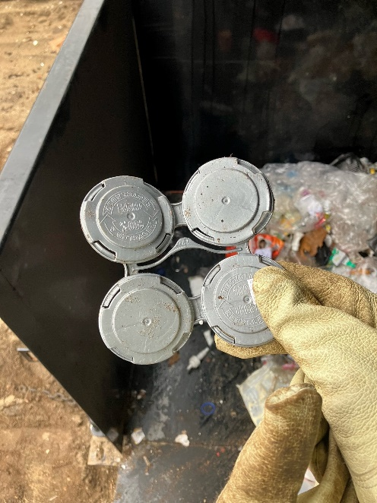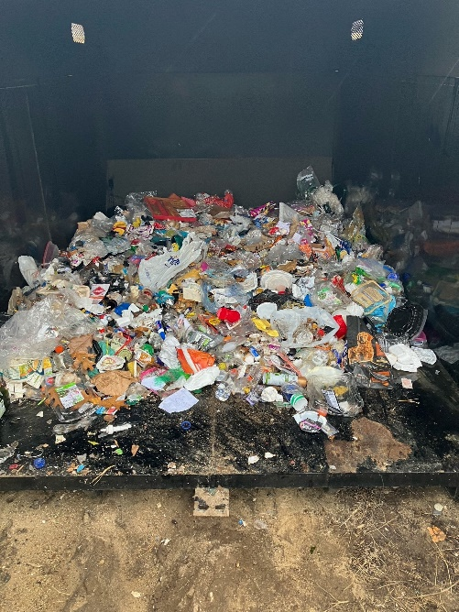
It also showed how clean our plastic and tin are overall. It was encouraging to find more than a few ketchup, mayonnaise, and peanut butter jars washed out before being tossed. All the people who have been doing that deserve praise. Its counter productive to have high value plastic become trash only because its dirty. That will be another outreach goal.
We learned the rate of Tin cans in our Comingled. This will be useful in deciding if it is worth it to separate Tins and send them to the scrap yard, as Eastham does. As this is written, average prices for tin cans are $140/ton. We currently PAY $65/ton to dispose of Comingled. The logistics if that’s feasible will need to be figured out but we now know. Over ¼ of our Comingled is valuable Tin.
Observations made throughout our audit revealed that people clearly think sunglasses and rigid six-pack holders are recyclable when they are not. Those items came up frequently and will become another part of our focus.
Another point of interest was that we only found about 6 Nip bottles. These cannot be recycled in our collection system due to their size but clearly, we do not see very many in the Recycling stream.
The most important things we will address are the syringes and medical waste that we found. If we found 5 needles in 20% of the load, there could be upwards of 20 more inside that container. For most people, when their waste gets thrown into a bin, it’s the last time they think about it. But that material will pass by dozens of people on its journey through the recycling process. It bears mentioning that Waste and Recycling workers are consistently around the 5th or 6th deadliest jobs in the U.S., behind Fishing, Logging, Roofing, Construction, and Aircraft pilots. We need to direct people to properly dispose of hazardous items.

CONCLUSION
The audit was a successful learning experience that provided valuable data which will be used to help us help people be better recyclers, create a higher quality material, increase the chances of items being recycled downstream, and save the Town money by taking advantage of the markets when available.
If we are to conduct another audit, we will have a better understanding of how to design it. It might be useful to know the percentages of different plastics and types of contaminants but that would require a faster sorting system and far more people.
Working with AmeriCorps was a pleasure, as always. Previously, they helped us with our Boat Shrink wrap recycling project and took on this even filthier job with enthusiasm and hard work. We could not have completed this project without them.
We also need to thank Steven Sette Ducati and Justin Pechonis. Steve volunteered his drone photography services to record this event and helped sort material. Justin ran double duty, managing the part of the Recycling area that was open and coming back to the audit to shovel and sort.
It became clear how time consuming something like this is. We hoped to sort an entire 40-yard container in a day. We managed about 10 yards in 4.5 hours and that’s with eliminating 7 categories we had hoped to sort. Another way to do an audit could be to take a smaller sample from a container and dissect it more thoroughly.
Some of these data points don’t mean very much now but if more audits are done in the future, even by other entities, they will be a useful comparison.

