Wellfleet Selectboard

Town Hall – 300 Main Street

Wellfleet, MA 02667
FOR IMMEDIATE RELEASE Contact: Barbara Carboni, Chair of Selectboard
Ryan Curley, Chair of Maurice’s Planning Committee
Phone: 508-349-0305
Email: Bos@Wellfleet-Ma.Gov
Wellfleet, Massachusetts, March 13, 2024
Wellfleet announces selection of Master Planners for Maurice’s Campground as next step to Address Year-Round Affordable Housing Crisis
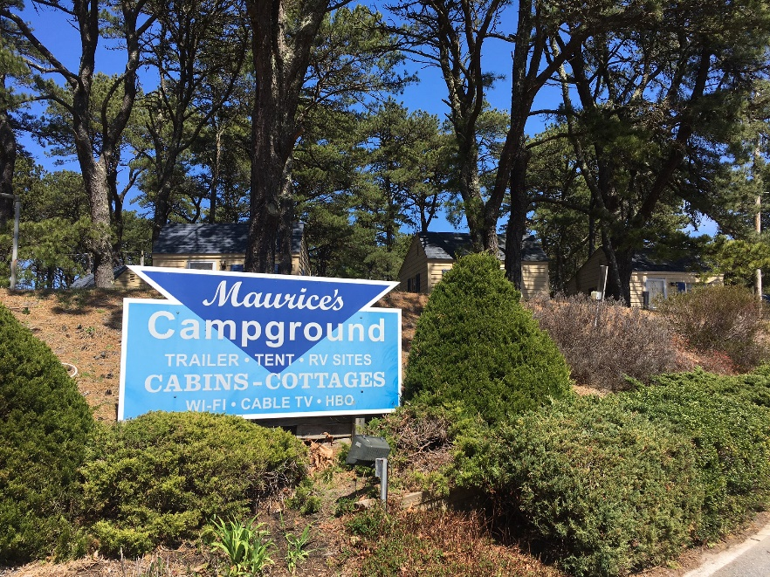
The Wellfleet Selectboard and the Maurice’s Planning Committee are very pleased to announce the selection of a strong team of Architects, Community Planners, Engineers and Financial Analysts to provide master planning services for the 21.25 acres known as Maurice’s Campground. The proposal selected is that of Studio G Architects of Jamaica Plain and Wellfleet. Gail Sullivan, managing principal of Studio G also designed Lawerence Hill Affordable rentals in Wellfleet which will soon begin construction. “The Planning Committee was very impressed with the completeness, creativity and enthusiasm expressed in the Studio G proposal and the interview session that followed,” states Ryan Curley, Chair of the Committee. Sullivan will lead a team which also includes JM Goldson for Community engagement, Langan Engineering for site planning and Boston Communities for financial feasibility.
The Committee was pleasantly surprised to receive six strong responses to a Request for Proposals released October 23, 2023. (The RFP is available on wellfleethousing.org.) The RFP outlined the Planning Committee’s ambitious goals of providing Affordable rentals, opportunities for year round home ownership AND some amount of housing for the many seasonal workers who Wellfleet welcomes and relies on to keep businesses open and vibrant in the summer. Energy efficiency and possible commercial opportunities were also on the list of goals. Additionally, as outlined in the RFP, the Planning Committee hopes for Maurice’s to be planned as a welcoming neighborhood and a good neighbor to the existing community located in this South Wellfleet location. Wellfleet’s Interim Town Administration, Tom Guerino states that he is “pleased to be involved in this important project so early in the planning process and imagines that it will be a wonderful addition to the community.”
Following the December19th deadline for submission of proposals the Planning Committee met 15 times to carefully review each proposal. Three were found to not meet the requirements of the RFP and the remaining three were studied in much further detail. According to Gary Sorkin, “While we were satisfied that any of the final three could do a good job of developing a master plan for Maurice’s, Studio G consistently earned the highest scores across the board in the matrices of Overall Firm/Team Experience, Diversity of Experience (Neighborhood Planning, Site Design, Architecture, Affordable Housing Development, Community Engagement), Project Management Experience, and Creativity. It was an enthusiastically unanimous decision to recommend Studio G.”
Following the Selectboard decision to accept the Committee’s recommendation and after the contract has been signed, Studio G will begin work in later April. The work is expected to take at least a year. All parties involved recognize that the engagement of all sectors of the Wellfleet community is paramount to a good outcome. There will be extensive outreach and multiple opportunities for the community to express wishes, goals, expectations and concerns for this next effort of increasing year-round, affordable housing opportunities. As Sharon Rule-Agger, Maurice’s Planning Committee member notes, “We are very pleased with the Selectboard’s decision to go with Studio G for a number of reasons including this team’s proposed robust community engagement process. We hope the Wellfleet community really gets involved from the outset to make this truly OUR project.”
Updates and additional information regarding this will be available as the process goes forward.
Sincerely,
Wellfleet Selectboard
Maurice’s Planning Committee

