NRAB-Harbor Management Plan 2020

Climate Change

Climate change has become a major new issue for the Town. Climate change, due to global warming, is a well established fact. All the evidence – and common sense – indicates that the effects will more consequential over the next years.

Wellfleet Harbor will see a number of consequences:

> Sea Level Rise
> Increase winds and storms
> Increased rainfalls
> Warmer harbor waters
> More acidic harbor waters

The consequences of warmer and more acidic harbor waters are mostly felt by the shellfishing community. These are discussed in a separate chapter.

Sea Level Rise

Sea level rise is perhaps the most dramatic new issue facing the Town. As consequence of both warmer sea waters and glacial melting, sea levels are rising globally. In addition, Cape Cod has been geologically sinking, which augments the effect.

Some NOAA predictions are shown in the following graph. There is a wide range of long term predictions. Recently, the more dramatic of these predictions seem more likely.

We note however that, for all the models, the main rise in sea level is predicted for 2030 and beyond.
This is important. The good news is that we thus have some time to plan and take steps to limit local consequences of climate change.

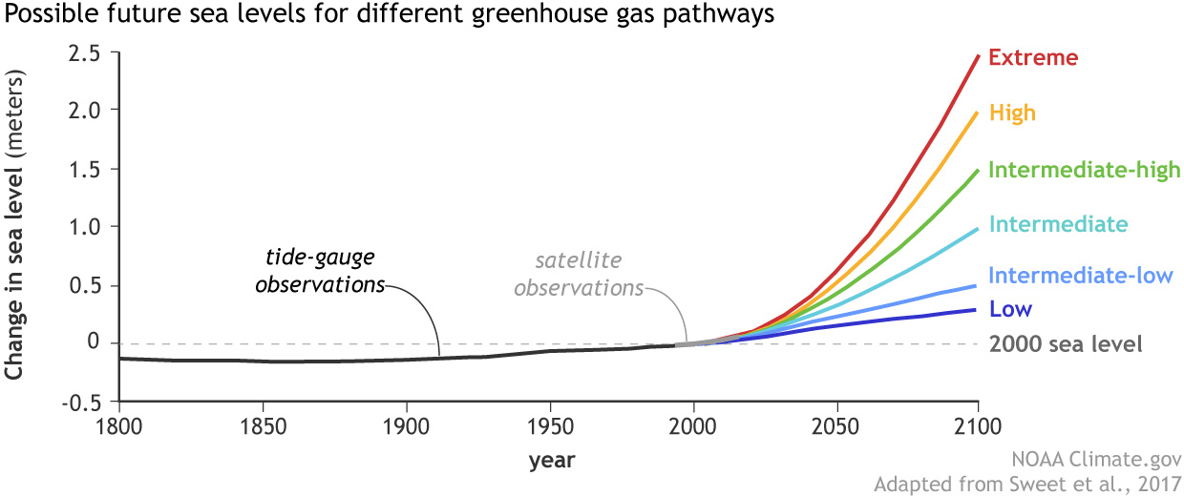

NOAA_SLR_projections_2017_lrg.jpg

Sea level rise will increase tidal flooding of the salt marshes of the harbor. Salt marshes are critical sources of nutrients and life for the harbor, so any loss of marshes or their efficiency would be a major concern for Wellfleet Harbor.
Normally, salt marshes maintain their elevation above sea level by retaining silt and other sediments carried by flood tides as shown by the classic work of J. Teal (ref). Existing salt marshes have, of course, been able to keep pace with historical sea level rise by migrating inland.
The prediction and understanding of the effects of sea level rise on salt marshes is an active area of research. Techniques from sophisticated modelling to field science, such as the use of the lead-210 isotopes to measure the historical rates of salt marsh elevations. An example of a local application of this technology from the USGS is:
https://www.sciencebase.gov/catalog/item/5a748e35e4b00f54eb19f96c

The research laboratories at the Cape Cod National Seashore (CCNS) have underway a program of regular salt marsh monitoring. The work is led by Dr Steve Smith. The work includes
measures of salt marsh elevations (hypsometry), vegetative changes and predictions of the ability of local salt marshes to sustain sea level rise as a flooded marsh edge meets adjoining inland dunes.

REFERENCES HERE

The work has been tested on marshes owned by the Cape Cod National Seashore, such as Middle Meadow and Nauset Marsh.
Marshes bordered with gradual dune slopes have a good prospect of sustaining sea level rise, at least in the short term. Of course, there is a vegetative change from salt marsh hay (Spartina patens) to Cordgrass (S. alterniflora). However, exposed marshes – as in the center of Nauset Marsh – are at high risk.

This monitoring should be extended to north and east side Wellfleet harbor marshes, such as Duck Creek, Blackfish Creek and Lt Island.

There are several additional specific concerns:

> As we have already seen around Wellfleet Harbor, shore line armoring by revetments prevents this. However, thus far, shore lines with gradual slopes have been mostly left in a natural state. The Conservation Commission is evaluating changes in regulations that will help
preserve all these shorelines. These regulations deserve Town support.
> It is also important to consider restoration of the upland reaches of some salt estuaries, even if the area is small. These would provide additional expansion space for the harborside estuaries and marshes. Three possibilities are Blackfish Creek, east of Route 6, Trout Brook (which, as named, has been the home to Sea Trout breeding ground) and Fox Island.

> Salt marshes in the south of the harbor, such as on Lt Island, lack dune backing and are also more open to shoreline erosion. Actual marsh protection using low lying breakwaters or oyster reefs to help protect against wind shoreline erosion should be kept in mind. Local examples are Provincetown and Winthrop.

> A further remediation strategy requires using harbor or other sediments to replenish or accelerate the raising of salt marsh elevations to keep pace with sea level rise. The technology is known as “thin layer deposition – TLD”. One example of work is at Delaware Bay:
https://www.fws.gov/refuge/Prime_Hook/what_we_do/marshrestoration.html

and in Rhode Island: http://www.crmc.ri.gov/news/2016_1007_marsh.html .

This topic directly connects to a long term dredging strategy and is discussed in that chapter.

Finally, Wellfleet has about 1250 acres of salt marshes. Restoration of the Herring River and Mayo Creek will add dike protected 1100 acres to this. In a sense we have an insurance policy. However, a major change in the long term balance between south and north harbor may produce consequences that are hard to predict.

Wind and Storms
Increasing global temperatures will lead to increases in wind energy and velocity. This may manifest itself particularly in increased storm frequency and intensity. For the harbor, the main consequence will likely be increased marsh and shoreline erosion. The risk would be greatest near the south end of the harbor, such as Lt. Island and Jeremy Point.
A program to monitor at these locations for wind and wave energy is warranted.

Precipitation Increase
The predictions for New England are a climate change driven increase of about 10% in precipitation, primarily as rain. There are two consequences.
First, there will be an increase in fresh water flow into the harbor from all upland sources, tending to decrease harbor salinity. There is also an increased contamination concern. A review of the Town’s culverts system is recommended.
Second, ground water levels in the aquifers under Wellfleet will rise. Operations of septic systems will be adversely affected, leading to potentially greater nitrogen flows into harbor waters. This issue is under consideration by the Town Board of Health.

There are many references and people who have provided ideas and results. for this plan. We wish to especially acknowledge the report by Dr. Seth Tuler, working with an ad hoc town committee. Though focused on shellfishing, the report has broad harbor applicability. The report is still timely, even if dated 2015. The report can be found on the NRAB web-page or from the link:

https://www.wellfleet-ma.gov/sites/g/files/vyhlif5166/f/file/file/climate_change_-_potential_impacts_on_shellfish.pdf

Resiliency Program, through the efforts of the Town Conservation Agent. This deserves our full support.

> Monitor current and past growth rates of marshes in Wellfleet – determine which marshes are at greatest risk
Action by: NRAB

> Restore marshes as available to optimize inland migration options
Action by: NRAB, Conservation Agent, Dredging Task Force

> Support Cons Com proposal for protecting upland slopes and ACEC lands to allow marsh migration
Action by: Selectboard, NRAB

> Investigate ways to protect marshes, including use of dredge spoils
Action by: NRAB, Dredging Task Force

