NRAB-Harbor Management Plan 2021

Chapter 1 - Introduction

This is the third Harbor Management Plan (HMP), after those of 1995 and 2006.

We are encouraged by the progress in the past 25 years. We have two useful
Harbor management plans. We have the formation of the Friends of Herring River. We have 18 years of Wellfleet Harbor Conferences. Both the Wellfleet Conservation Trust and the Wellfleet Bay Sanctuary have contributed to the harbor well being. Other non-profits such as the Provincetown Center for Coastal Studies (CCS) and the Association to Preserve Cape Cod (APCC) are active here . The Cape Cod National Seashore (CCNS) owns much of the western harbor and Herring River: it is active in conservation science and policy. We have excellent work by many Town committees. The goal of this plan is to suggest ways to continue forward.

In the 1995 Harbor Management Plan, the key issue was harbor cleanliness. This was addressed in years following by a nearly universal adoption of Title V septics.
This report can be accessed on the Town of Wellfleet web-site, under NRAB:
< https://www.wellfleet-ma.gov/sites/g/files/vyhlif5166/f/file/file/1995plan.pdf>.

The 2006 report also had a focus on harbor water quality, due then to excess nitrogen. A second key issue was tidal restoration of marshes that were isolated by diking, especially the Herring River and Mayo Creek estuaries. Link is:
https://www.wellfleet-ma.gov/sites/g/files/vyhlif5166/f/file/file/harbor.pdf

Work on several of the issues from 1995 and 2006 is on-going. We recommend as high priorities that these projects be supported to completion:

> Nitrogen. The Comprehensive Waste Water Planning Committee is working on a plan.
> Herring River restoration. The project is in the midst of the permitting process.
> Mayo Creek restoration. A draft plan needs implementation.
> Harbor dredging. Not a priority in 2006 but became one due to cost and scheduling
Issues. A good plan is in place which needs to be fully implemented.

In addition, there are some important new initiatives which merit Town support:

> Shoreline Protection – New regulations are being drafted by the Conservation Commission
> Coastal Resiliency. A four Town shoreline management project is underway; the Wellfleet representative is the Town Conservation Agent. An initial report has been issued by CCS:.
https://www.wellfleet-ma.gov/sites/g/files/vyhlif5166/f/news/wellfleet-truro_mvp_report.pdf

In the longer term, a broad-based Town “Climate Change” committee is warranted. It will not be possible to separate conservation issues from shellfishing issues from health issues from shoreline structures issues. Consider, for example, Mayo Beach. From the harbor inland there are: shellfish grants, tidal flats, the beach itself, parking, Kendrick Road, private homes and Mayo Creek marshes. A broad view is needed.

- There are four chapters in the 2021 HMP:

I Climate Change and its effect of the harbor – especially sea level rise and temperature Increase. We note that this key issue was not even mentioned
In 1995 or 2006.

ii. Survey of harbor life. This is an update of the 1975 “Curley” report. The goal is
to provide a useful basis for tracking harbor changes.

iii. Dredging. This is perhaps better known as “after-dredging”. The goal is to
find ways to minimize future dredging and to make better use of dredge “spoils”.

iv. Shellfishing. A review of steps that might be considered to enable the wild
shellfish populations in the harbor to flourish, as an environmental and commercial benefit.

Finally, we are of course aware of possible social consequences of climate change. For example increased tidal flooding of road and uplands, for example east Commercial Street, Mayo Beach and Lieutenant Island is likely. These concerns are outside the scope of this report: we note that adequate Town planning is needed to minimize damages.

Chapter 1 – Recommendations

> Emphasize and complete key on-going projects, as listed.
Action by: Selectboard, and appropriate Town committees and staff

> Create a “Climate Change Committee”, staff and citizens, to oversee and co-ordinate response to climate change and sea level rise.
Action by: Selectboard

> Energy Committee co-operation with other Towns on Cape Cod and in Massachusetts to take advantage of the pioneering greenhouse gas reduction work done here.
Action by: Energy Committee

NRAB-Harbor Management Plan 2021

Chapter 2 - Climate Change

Climate change has become a major new issue for the Town. Climate change, due to global warming, is a well established fact. All the evidence – and common sense – indicates that the effects will more consequential over the next years.

Wellfleet Harbor will see a number of consequences:

> Sea Level Rise
> Increase winds and storms
> Increased rainfalls
> Warmer harbor waters
> More acidic harbor waters

The consequences of warmer and more acidic harbor waters are mostly felt by the shellfishing community. These are discussed in a separate chapter.

Sea Level Rise

Sea level rise is perhaps the most dramatic new issue facing the Town. As consequence of both warmer sea waters and glacial melting, sea levels are rising globally. In addition, Cape Cod has been geologically sinking, which augments the effect.

Some NOAA predictions are shown in the following graph. There is a wide range of long term predictions. Recently, the more dramatic of these predictions seem more likely.

We note however that, for all the models, the main rise in sea level is predicted for 2030 and beyond.
This is important. The good news is that we thus have some time to plan and take steps to limit local consequences of climate change.

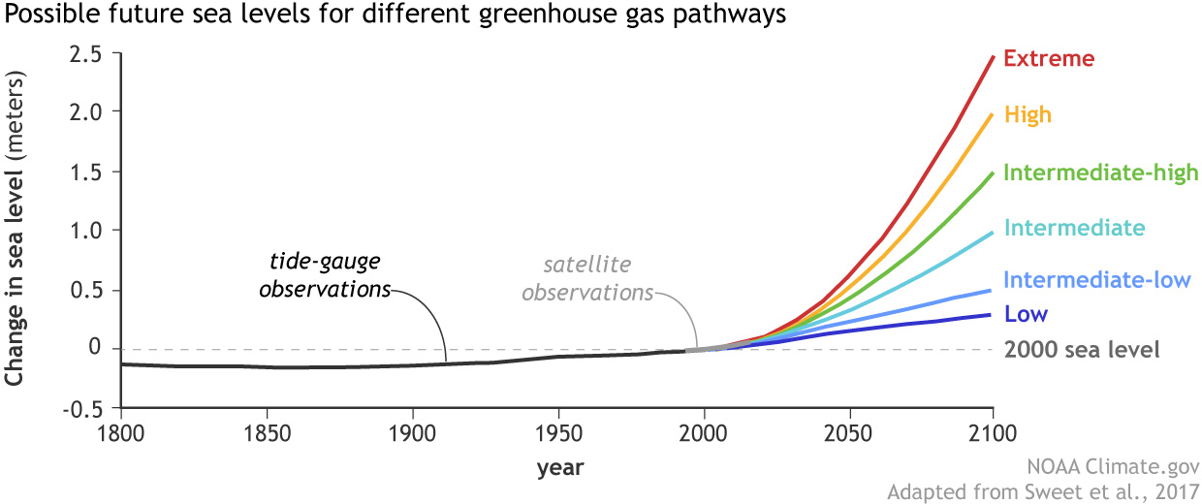

NOAA_SLR_projections_2017_lrg.jpg

Sea level rise will increase tidal flooding of the salt marshes of the harbor. Salt marshes are critical sources of nutrients and life for the harbor, so any loss of marshes or their efficiency would be a major concern for Wellfleet Harbor.
Normally, salt marshes maintain their elevation above sea level by retaining silt and other sediments carried by flood tides as shown by the classic work of J. Teal (ref). Existing salt marshes have, of course, been able to keep pace with historical sea level rise by migrating inland.
The prediction and understanding of the effects of sea level rise on salt marshes is an active area of research. Techniques from sophisticated modelling to field science, such as the use of the lead-210 isotopes to measure the historical rates of salt marsh elevations. An example of a local application of this technology from the United States Geological Service (USGS) is:
https://www.sciencebase.gov/catalog/item/5a748e35e4b00f54eb19f96c

The research laboratories at CCNS have underway a program of regular salt marsh monitoring. The work is led by Dr Steve Smith. The work includes measures of salt marsh elevations (hypsometry), vegetative changes and predictions of the ability of local salt marshes to sustain sea level rise as a flooded marsh edge meets adjoining inland dunes.

Salt marsh monitoring:
https://www.wellfleet-ma.gov/sites/g/files/vyhlif5166/f/uploads/2013_sm_monitoring_report_-_unrestricted_marshes-final.pdf

Salt marsh migration:
https://www.wellfleet-ma.gov/sites/g/files/vyhlif5166/f/uploads/coas-36-05-09_1.9_proofs_sms_edits.pdf

Salt marsh elevation growth:
https://www.wellfleet-ma.gov/sites/g/files/vyhlif5166/f/uploads/smith_et_al_2016_hypsometry_of_cape_cod_salt_marshes.pdf

The work has been tested on marshes owned by the Cape Cod National Seashore, such as Middle Meadow and Nauset Marsh. Similar results have been obtained by research on the Newbury Great Marsh in Essex County sponsored by the Trustees of Reservations (TToR).

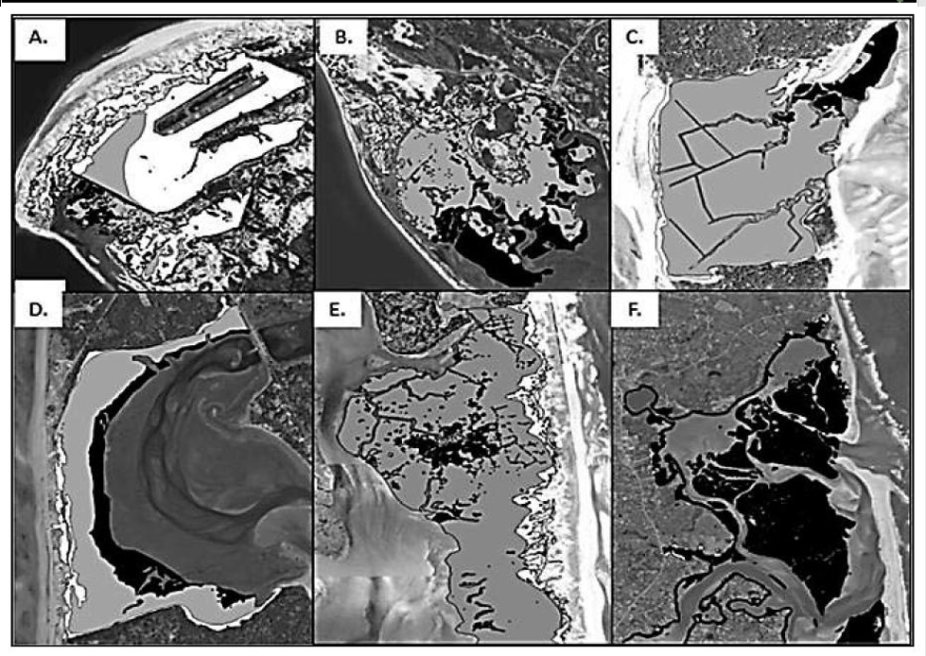
Estimations of marsh changes without land-use or slope
constraints in a 1-m SLR scenario. Black polygons are marshes that have
been lost, gray polygons are present-day marshes, and white polygons are
potential marsh habitats with landward migration. A.Hatches Harbor, B.
West End, C.Middle Meadow, D.Gut, E.Pleasant Bay, F.Nauset; PB
and NS figures show only portions of those systems to provide adequate
resolution.

The work is based on on marshes owned by the Cape Cod National Seashore.
Marshes bordered with gradual dune slopes have a better chance of sustaining sea level rise, at least in the short term. From the Gut (site D), we can see predicted loss of marshland is at least somewhat compensated by a small upland increase.
However, a marsh such as in Nauset Harbor (site F), which sits in the center of the estuary, is predicted to be lost entirely.

Important marsh vegetative changes are also observed. Hign marsh salt marsh hay (Spartina patens) is being replaced by low marsh to Cordgrass (S. alterniflora). The consequence is a loss in marsh biodiversity.

Salt marsh monitoring should be extended to north and east side Wellfleet harbor marshes, such as Duck Creek, Blackfish Creek and Lt Island (see Recommendations).

There are several additional specific concerns:

> As we have already seen around Wellfleet Harbor, shore line armoring by revetments prevents this. However, thus far, shore lines with gradual slopes have been mostly left in a natural state. The Conservation Commission is evaluating changes in regulations that will help
preserve all these shorelines. These regulations deserve Town support.
> It is also important to consider restoration of the upland reaches of some salt estuaries, even if the area is small. These would provide additional expansion space for the harborside estuaries and marshes. Three possibilities are Blackfish Creek, east of Route 6, Trout Brook (which, as named, has been the home to Sea Trout breeding ground) and Fox Island.

> Salt marshes in the south of the harbor, such as on Lt Island, lack dune backing and are also more open to shoreline erosion. Actual marsh protection using low lying breakwaters or oyster reefs to help protect against wind shoreline erosion should be kept in mind. Local examples are Provincetown and Winthrop.

> A further remediation strategy requires using harbor or other sediments to replenish or accelerate the raising of salt marsh elevations to keep pace with sea level rise. The technology is known as “thin layer deposition – TLD”. One example of work is at Delaware Bay:
https://www.fws.gov/refuge/Prime_Hook/what_we_do/marshrestoration.html

and in Rhode Island: http://www.crmc.ri.gov/news/2016_1007_marsh.html .

This topic directly connects to a long term dredging strategy and is discussed in that chapter.

Finally, Wellfleet has about 1250 acres of salt marshes. Restoration of the Herring River and Mayo Creek will add dike protected 1100 acres to this. In a sense we have an insurance policy. However, a major change in the long term balance between south and north harbor may produce consequences that are hard to predict.

Wind and Storms
Increasing global temperatures will lead to increases in wind energy and velocity. This may manifest itself particularly in increased storm frequency and intensity. For the harbor, the main consequence will likely be increased marsh and shoreline erosion. The risk would be greatest near the south end of the harbor, such as Lt. Island and Jeremy Point.
A program to monitor at these locations for wind and wave energy is warranted.

Precipitation Increase
The predictions for New England are a climate change driven increase of about 10% in precipitation, primarily as rain. There are two consequences.
First, there will be an increase in fresh water flow into the harbor from all upland sources, tending to decrease harbor salinity. There is also an increased contamination concern. A review of the Town’s culverts system is recommended.
Second, ground water levels in the aquifers under Wellfleet will rise. Operations of septic systems will be adversely affected, leading to potentially greater nitrogen flows into harbor waters. This issue is under consideration by the Town Board of Health.

There are many references and people who have provided ideas and results. for this plan. We wish to especially acknowledge the report by Dr. Seth Tuler, working with an ad hoc town committee. Though focused on shellfishing, the report has broad harbor applicability. The report is still timely, even if dated 2015. The report can be found on the NRAB web-page or from the link:

https://www.wellfleet-ma.gov/sites/g/files/vyhlif5166/f/file/file/climate_change_-_potential_impacts_on_shellfish.pdf

Resiliency Program, through the efforts of the Town Conservation Agent. This deserves our full support.

> Monitor current and past growth rates of marshes in Wellfleet – determine which marshes are at greatest risk
Action by: NRAB

> Restore marshes as available to optimize inland migration options
Action by: NRAB, Conservation Agent, Dredging Task Force

> Support Cons Com proposal for protecting upland slopes and ACEC lands to allow marsh migration
Action by: Selectboard, NRAB

> Investigate ways to protect marshes, including use of dredge spoils
Action by: NRAB, Dredging Task Force

NRAB-Harbor Management Plan 2021

Chapter 3 – Dredging

Wellfleet’s Marina is a busy center of activity in the Town, as has always been the case since colonial times.
Wellfleet Harbor is a shoaling harbor. At no time did deep-water vessels have full access to the harbor. Smaller ships did come into the Duck Creek harbor at high tides, before the Rail Road dike was finished (about 1875).
It follows that periodic dredging of Wellfleet Harbor is crucial to maintain harbor utility. A navigable harbor is essential for numerous economic and recreational reasons including the marina, commercial fishing, aquaculture, tourism, boating safety (and others ). However, due to costs and permitting issues, it is not certain that the current system can be relied upon in the future.

Dredging spoils have usually been deposited in deep water of Cape Cod Bay well away from the harbor. This has been seen to be the most efficient, economical , and presumably the safest way of dealing with the dredged material. Dredge spoils have been used to in the past for wetlands replenishment – for example in Chipman’s Cove – but this now prohibited by wetlands regulations. (see HMP 1, page 79)

However, spoils can be used in other ways. The Town of Truro uses dredged material from Payomet Harbor to replenish the Town Beach erosion. In Wellfleet, spoils from Keller’s Corner that are deposited at the L-shaped pier are regularly moved back to their initial location.

The larger goal in using these spoils is to facilitate local control and lower costs for needed harbor dredging.

A first needed step in this project is to analyze dredging spoils, for both project planning and permitting needs.

To this end, NRAB sponsored research at the Center for Coastal Studies (CCS) about the nature of “black mayonnaise” in the north marina channel:
https://www.wellfleet-ma.gov/sites/g/files/vyhlif5166/f/uploads/ccs_wellfleet_blackmayo_2020.pdf

Agnes Mittermyer was the lead author of the report. Funding was agreed to by the Town at the Annual Town Meeting in 2016. The report provides answers to these questions: where is it?, what is it?, how thick is it?, where does it come from?, and how does it move?

A termonolgy note: the term “black custard” is preferred by the study authors for the material in Wellfleet harbor. (Elsewhere, the term “black mayonnaise has been used to refer to a toxic material).

“Black custard” is a flocculated material, composed of silts and clay, bound in part by natural harbor organic algae. Our “black custard” consists of 70% fine grain sediment and 30% marine organic matter. The black color is from iron compounds. The odor was shown to be the result of hydrogen sulfide, a normal marsh gas produced due to oxygen deprivation.

No toxic organic or inorganic ingredients were found so that it is possible to consider broad options for use of this material for beach or marsh replenishment.

The particle size of the deposits is very sensitive to local tidal current flows: small currents lead to small particles and vice versa.
Particle size data is shown in the figure below, taken from the report. All of the samples were taken around the Marina pier except k (at the Gut) and g (at the Mayo Creek outfall). The lower dotted line is boat basin current velocities, the upper line is away from the basin. The data show the current velocities needed to transport sediments.

With these results, it makes sense to reconsider alternatives to north channel dredging.
The obvious targets are the marshes of Duck Creek and Mayo Creek, as these were the natural historical sites for tidal sediment depositions before development of the marina.

Currently, the tidal flow rates in the north marina channel are very low. Higher flow rates are needed to transport the black mustard. This could involve a yearly pumping of accumulated spoils from the north channel to the flow channel of Duck Creek. Restoration of Mayo Creek could provide also two benefits: deposition of black custard on the marsh during flood tides and increased flows during ebb.

Additional sediment transfer modelling will be a necessary, as originally suggested in the report by G.Geise at al in the 1995 Harbor Plan, including the effect of the railroad dike and the partial restoration of Mayo Creek.

A second option for inner harbor dredge spoils would be “Thin Layer Placement” (TLP) , a system of spraying a slurry of dredged material over marshes. As mentioned in the salt marsh chapter, this has been used to restore marshland in a number of southern and Atlantic Coast states. Extensive review of the current status of this method is available in Army Corps of Engineering websites. However, this is a new technology, needing significant developments, both for engineering and permitting. An advantage of the Duck/Mayo Creek estuary is that it would be possible to use the natural tidal cycle for deposition.

Spoils from immediately south of the marina – into Chipman’s Cove – have not been studied in detail. They are likely to be very similar to those in the north channel and could be used for salt marsh elevation in the Cove.

Further south in the harbor – such as Blackfish Creek – the use of TLD or other similar technologies is not obvious. It is critical there that
the way for marsh migration inland be preserved.

From the main channel, south of the breakwater out towards the bay, the spoils are mainly sand. (See the Bourne Engineering report:

https://www.wellfleet-ma.gov/sites/g/files/vyhlif5166/f/file/file/report_wellfleet_dredging.pdf).

These spoils could be used for sandy shoreline restorations, as already
used in Truro.

Of course, maintenance dredging and spoils transport is always a possibility with a Town owned or shared dredge if these other options are not practical.

Recommendations:

> Provide a grant to study feasibility of using dredge spoils from Wellfleet harbor to replenish marsh erosion, either directly or by using Thin Layer Deposition (TLD). Modelling will be required. Follow developments of TLD technology.
Action by: Dredging Task Force, NRAB

>Work with Center for Coastal Studies (CCS) and Association to Preserve Cape Cod (APCC), in evaluating potential cost/benefit of removing the old railroad bridge and other infrastructure modifications.
Action by: NRAB

>Work with Dredge Task Force in reviewing feasibility of maintenance dredging, including possible purchase or sharing of a dredge, training, permitting, etc.
Action by: Selectboard

NRAB-Harbor Management Plan 2020

Chapter 4 - Shellfishing

Shellfishing has been and remains an important part of Wellfleet’s social and economic life. It is the living for many residents. Continued success of the enterprise demands good management and a sound harbor environment.

As the historical work in the “Belding” report shows, management has failed in the past. Strong continuing leadership from the Shellfish Advisory Board and Shellfish Constable will continue to be needed.

Much of what NRAB could contribute to this discussion was already anticipated by a Climate Change Working Group Report, authored by Dr Seth Tuler, 2015, already referenced in the Introduction. It is still a key reference, which NRAB supports.

Climate change will result in several changes in the harbor environment that may affect shellfishing:

> warmer harbor waters
> more acidic harbor waters, due to increased CO2 dissolving in the harbor to
create higher carbonic acid (H2CO3) levels
> sea level rise itself with a risk of deeper waters for shellfish access
> new species entering the harbor that may compete with the current fauna
> increased precipitation could lead to an increase in contaminants from road run-off and septics.

Warmer Waters.

Climate change will lead to gradually warmer waters in the harbor. Shellfish can well adapt to these conditions: there is an important shellfish business on the south shore of Cape Cod, in Long Island sound and in Chesapeake Bay. Historically, these bays have been the source forWellfleet shellfish. It is important that our seed stocks continue to reflect this diversity, allowing normal biological processes to compensate for climate change.

Another warm water effect may be “phenology” a mis-match in the timing of shellfish breeding and spat release phyto-plankton blooms. We recommend monitoring of these blooms
As part of monitoring harbor health.

Harbor Acidity

Shellfish shells are basically calcium carbonate, which dissolves in acid waters. This leads to thinner, fragile shells. Increasing atmospheric carbon dioxide dissolved in harbor water will lead to increasing acidity due to the formation of carbonic acid.
Genetic diversity is again needed, to allow Wellfleet oysters to adapt and make strong enough shells.

Sea Level Rise.

Especially when the shoreline is dominated by revetments, sea level rise may lead to deeper average tidal depths. Shellfishing harvesting directly from boats may then become more important.

New Species

Not all changes will be harmful. Blood & Razor Clams, Blue-claw Crabs and increases in Bay Scallops can open new markets.

Apart from climate change, there are several other important topics to be addressed:

Upland water run-off.

Climate change predicts increased rain fall in the north-east. This will lead to an increased ground-water levels and road run-off. The rise in ground water levels may also impact performance of even Title V septics.
All of these effects could lead to contamination of harbor waters with a consequent risk to shellfish. . An overall review and plan to respond to these issues is needed.

Inner Harbor

Water quality in the inner harbor is also diminished by high nitrogen levels. Completion of te comprehensive waste-water program is essential.

Bay Scallops

Bay Scallops is a very profitable business. In the 1995 Harbor Plan, results of an experiment to enhance bay scallops was reported. For three years, dragging was prohibited in an area of the lower harbor. The result reported was an increase in Bay Scallops and their habitat, eelgrass.
This experiment should be repeated with a longer-term point of view, both for the scallops and for overall harbor health.

Harbor Shellfish Resources

We need to monitor the health of Wellfleet wild shellfish populations on a long term, regular basis. The last time this was done was in 1975.
NRAB is working with partners to re-start this program. The sites for sampling will need to be distanced from aquaculture locations to be sure that it is broad harbor health that is measured.

Plastics

Wellfleet shellfishers are properly worried about micro-plastics contamination of products. This has not been observed in Wellfleet harbor; it is a future risk.
As part of a harbor and cleanliness project, the shellfish department and board are
undertaking a project to reduce the use of plastic in shellfishing operations. However, should microplastics be found in local shellfish, obtaining a clean product for market would require
a new technology.

Shellfish Reefs

A concern for Wellfleet harbor is that a combination of sea level rise and wind speeds
would threaten salt marshes. A possible solution, in part, would be the establishment of a reef
barrier that would protect a marsh. In fact, “oyster reefs” have themselves been used as protective barriers. There have even been trials on Cape Cod sites, in Bourne.

If barriers of either sort be deemed necessary, the shellfish department would have to be closely involved in design, permitting and use.

Recommendations:

> Continue to ensure genetic diversity in Wellfleet shellfish, in response to warmer and more acidic waters
Action by: Shellfish Advisory Board (SAB), Shellfish Department

> Prioritize programs to reduce risk to harbor water quality due to sea level rise and increased rainfall negatively affecting road run-off and septic performance
Action by: Board of Health, Comprehensive Waste-water Committee

> Take advantage of positive trends such as Blood Clams & increased Bay Scallop opportunities
Action by: Shellfish Department

> An updated Shellfish Management Plan is needed.
Action by: Shellfish Advisory Board, NRAB support

NRAB-Harbor Management Plan 2020

Chapter 5 - Wellfleet Harbor Marine Resources

A major goal of NRAB is to help ensure that Wellfleet harbor remains a clean and productive site for residents and those who earn their living directly from harbor waters.

Monitoring of harbor waters and biology is an important part of achieving this goal.
Back in 1972, the Division of Marine Fisheries produced a comprehensive report to this end entitled “A Study of the Marine Resources of Wellfleet Harbor”. The lead author was John R. Curley, so we refer to it as the Curley Report

One of the recommendations of the report was that the survey be repeated every 10 years. This was clearly not done. We recommend a renewal of the report, which would provide a guide for an action plan based on nearly 50 years of changes.

The Curley report has a number of sections:

> harbor morphology
> Benthic fauna
> water quality: temperature, oxygen, pH
> Finfish, both bait and sport
> Shellfish
> Marine and Marsh vegetation
> Other harbor monitoring,
> Economics of Harbor related activities

Harbor Morphology.

The original report has a basic but still useful depth contour map of the harbor . A more detailed study of the benthic harbor habitat was issued in 2019 by the
Center for Coastal Studies:
https://www.wellfleet-ma.gov/sites/g/files/vyhlif5166/f/uploads/wellfleet_harbor_benthic_habitat_report_19cl08.pdf

This report can also be found on the NRAB web-page.

Benthic fauna

The same study which surveyed harbor morphology also reported on benthic life
In the harbor.

Water Quality

Much more extensive water quality testing is on-going, lead by Amy Costa at
The Center for Coastal Studies. A link to this data is: xxx. Crucially, this data also contains
information on harbor nitrogen and phosphorous, the importance of which has become
better understood in recent years.

Finfish

Nine finfish stations were established in 1968 (map attached). Sampling used a 60’ beach seine and an otter trawl in deeper water. Data was taken monthly.
Key baitfish were Silversides, Mummichog and Striped Killifish. Winter Flounder, Alewife, and Menhaden were also significant among the larger fish. Interestingly, neither Bluefish nor Striped Bass were found. This was attributed to those species ability to avoid the sampling nets rather than absence from harbor waters.

Work on finfish populations is already well underway. The Center for Coastal Studies (CCS), Owen Nichols as lead scientist, is completing field work for a study of baitfish. A final report is being written. This work was funded by a Palladino Fellowship from the Friends of Herring River.
A follow-up proposal has been prepared, also by CCS, for a larger project to sample the harbor for commercial and sport fish.
Finally, for many years the Friends of Herring River has sponsored a volunteer count of the Spring herring run in the river. A summary of data follows:

Year | Fish | Count | Statistical | First | Last | Peak | Peak
 | Counted | Sessions | Estimate | Sighting | Sighting | Count | Date
2009 | 1663 | 235 | 22,000 | 7-Apr | 25-May | 131 | 18-Apr
2010 | 744 | 265 | 12,500 | 4-Apr | 30-May | 61 | 7-Apr
2011 | 645 | 340 | 9,500 | 9-Apr | 26-May | 111 | 27-Apr
2012 | 1192 | 465 | 11,700 | 19-Mar | 24-May | 122 | 9-Apr
2013 | 2035 | 383 | 25,000 | 6-Apr | 26-May | 220 | 26-Apr
2014 | 4903 | 325 | 60,000 | 9-Apr | 26-May | 320 | 14-Apr
2015 | 1561 | 303 | 18,000 | 11-Apr | 25-May | 208 | 26-Apr
2016 | 1379 | 347 | 12,900 | 28-Mar | 18-May | 143 | 26-Apr
2017 | 673 | 284 | 8,000 | 7-Apr | 18-May | 177 | 11-Apr
2018 | 2426 | 304 | 27,000 | 11-Apr | 25-May | 288 | 29-Apr
2019 | 3244 | 318 | 46,000 | 7-Apr | 27-May | 214 | 8-May
2020 | 1591 | 485 | 13,200 | 27-Mar | 21-May | 81 | 30-Apr

Restoration of the Herring River will provide a major opportunity for change: data from that project will continue to be important.

Shellfish.

There is extensive shellfish data in the Curley report, especially for Quahog and Oyster.
We also have data from the early 1900’s due to the research of Dr. David Belding. Very useful commercial data is compiled annually by the Shellfish Constable.

However, a direct comparison with modern data for the purpose of monitoring overall harbor health will be difficult. There have been two significant changes in the intervening 45 years:
> the use of aquaculture for commercial shellfishing has become a key part of the shellfishing business. Many of the test sites in the earlier study are now used for aquaculture.
Sites will need to be identified that are wild growth only: the Fresh Brook estuary, west side location along Great Island south to Jeremy Point, and parts of the Gut.

> cultching has become a widely used and effective tool to encourage shellfish propagation. The study could compare cultched and native sites that are adjacent or nearly so: Chipmans Cove and the Gut are possibilities.

These changes have benefitted shellfish populations in the harbor. Aquaculture provides a source for “spat” – young oysters and clams. Cultching provides habitat for oyster spat to adhere and grow.

However, in order to use shellfish information to monitor long term general harbor quality, we will need to effectively start over. Therefore, comparisons back to Curley, or even David Belding’s works will be difficult. Probably, we will need more repetitions of shellfish data.
Co-operation with the Shellfish Constable and SAB will be essential.

Sampling decisions that need to be considered are:
> cultched versus totally wild sampling sites;
> harbor east (where most of the marshes are located) versus harbor west (fewer marshes) and harbor north (protected waters) versus harbor south (open waters)
> The Curley report took no mid-harbor samples. Dragging for shellfish is an important
tool for the shellfish business in Wellfleet. For mid-harbor data to be useful, some short- term designation of dragging sanctuaries would be needed.

Marine life

Shellfish live on phytoplankton. The abundance of these microscopic algae is critical to the populations of shellfish. In addition, the blooms of phytoplankton relative to spat release by
breeding shellfish is important. This is the phenomenon called “phenology”. So, measures
of phytoplankton blooms compared to shellfish spat release could be a critical measure
of the health of the harbor.

Marsh Vegetation

Monitoring salt marsh vegetation changes is discussed under a “Climate change” chapter.

> Other harbor monitoring.

There is already underway various harbor monitoring projects, of great value, which deserve support:

- Diamond-backed Terrapins, Horseshoe Crabs : MassAudubon

Note: Horseshoe Crab populations in the harbor are greatly reduced; these crabs
greatly benefit shellfishing beds. We need to work further with the Division of Marine Fisheries on a strategy to build populations in Wellfleet harbor.

- Eels ; MassAudubon

Note: there is a spring migration monitoring site at the Wellfleet Bay Sanctuary. This monitoring should be expanded; for example to Hawes Pond
and the Herring River

- Birds : perhaps the most interesting data could be obtained in the winter;
for examples, Eider eat small shellfish; Loons and Merganser eat small fish.

A conclusion from this summary is that many of the monitoring test data already exists or is currently underway. The biggest gap is for larger, sport fish. The main resulting challenge will be to put the range of results together in a useful report.

Chapter 5 – “Curley Report” [Monitoring of Wellfleet Harbor]

> Complete and report results of a renewed monitoring of Wellfleet Harbor, with an appropriate action plan.
Action by: NRAB

NRAB – Harbor Plan - 2020 Draft Summary of Recommendations

Chapter 1

> Emphasize and complete key on-going projects, as listed.
Action by: Selectboard, and appropriate Town committees and staff

> Energy Committee co-operation with other Towns on Cape Cod and in Massachusetts to take advantage of the pioneering green house gas reduction work done here.
Action by: Energy Committee

Chapter 2 – Climate

> Monitor current and past growth rates of marshes in Wellfleet – determine which marshes are at greatest risk
Action by: NRAB

> Restore marshes as available to optimize inland migration options
Action by: NRAB, Conservation Agent, Dredging Task Force

> Support Cons Com proposal for protecting upland slopes and ACEC lands to allow marsh migration
Action by: Selectboard, NRAB

> Investigate ways to protect marshes, including use of dredge spoils
Action by: NRAB, Dredging Task Force

Chapter 3 – Dredging

Provide a grant to study feasibility of using dredge spoils from Wellfleet harbor to replenish marsh erosion, either directly or by using Thin Layer Deposition (TLD). Modelling will be required. Follow developments of TLD technology.
Action by: Dredging Task Force, NRAB, CCNS – Cape Cod National Seashore

>Work with Center for Coastal Studies (CCS) and Association to Preserve Cape Cod (APCC), in evaluating potential cost/benefit of removing the old railroad bridge and other infrastructure modifications.
Action by: NRAB

>Work with Dredge Task Force in reviewing feasibility of maintenance dredging, including possible purchase or sharing of a dredge, training, permitting, etc.
Action by: Selectboard

Chapter 4 – Shellfishing

> Continue to ensure genetic diversity in Wellfleet shellfish, in response to warmer and more acidic waters
Action by: Shellfish Advisory Board (SAB), Shellfish Department

> Prioritize programs to reduce risk to harbor water quality due to sea
level rise and increased rainfall negatively affecting road run-off and septic performance
Action by: Board of Health

> Take advantage of positive trends such as Blood Clams & increased Bay Scallop opportunities
Action by: SAB, Shellfish Department

Chapter 5 – “Curley Report” [Monitoring of Wellfleet Harbor]

> Complete and report results of a renewed monitoring of Wellfleet Harbor, with an appropriate action plan.
Action by: NRAB

